From Forecasting to Trading: A Practical Approach to Rare Earth Minerals
Arnav Goel, Ananya, Arjun

Highlights
This paper presents a decomposition-based hybrid framework for forecasting and trading rare earth mineral prices. The framework introduces an entropy-guided classification of decomposed signal components, enabling targeted assignment of linear and nonlinear models to deterministic and stochastic components, respectively. Sparse feature selection is performed via LASSO at the component level, ensuring that only the most relevant macroeconomic and sentiment-driven predictors are retained for each frequency band. The hybrid ARX–LSTM architecture achieves forecasting accuracy of approximately 2.5% MAPE across all assets examined. An interval-based trading strategy, which incorporates prediction confidence bounds, yields Sharpe ratios exceeding 2 while significantly reducing maximum drawdowns compared to conventional directional approaches.

Abstract
This study proposes a novel decomposition-based hybrid forecasting framework for modeling and trading highly volatile commodity markets, with a specific focus on rare earth mineral prices. Given the nonlinear, non-stationary, and noise-driven nature of such markets, the framework integrates Variational Mode Decomposition (VMD) to decompose raw price series into multiple intrinsic mode functions representing distinct frequency dynamics. Approximate Entropy (ApEn) is employed to classify decomposed components into low-complexity and high-complexity modes, thereby enabling data-driven model assignment (Pincus, 1991). A LASSO-based feature selection procedure is applied to identify the most relevant macroeconomic, financial, and sentiment-driven predictors for each component, enhancing model parsimony and robustness (Tibshirani, 1996). For forecasting, a hybrid ARX–LSTM architecture is implemented, where ARX models capture linear dependencies in low-frequency components while Long Short-Term Memory networks model nonlinear dynamics in high-frequency components. To translate predictive accuracy into economic value, an interval-based trading strategy is developed using a neural network to estimate confidence bounds, allowing trades only under conditions of sufficient certainty. Empirical results demonstrate that the proposed framework significantly outperforms benchmark models, achieving forecasting accuracy of approximately MAPE ≈ 2.5%. Furthermore, the interval-based trading strategy yields substantially improved risk-adjusted returns, with Sharpe ratios exceeding 2, while effectively mitigating maximum drawdowns.

Keywords
Rare Earth Markets; Variational Mode Decomposition; Approximate Entropy; LASSO; LSTM; ARX; Hybrid Forecasting; Algorithmic Trading; Risk Management

1. Introduction
Rare earth minerals are essential inputs in a wide range of modern technologies, including renewable energy systems, electric vehicles, and advanced electronics. As global economies accelerate toward decarbonization and technological advancement, the demand for these materials has grown significantly, while the supply remains highly concentrated geographically. These structural characteristics contribute to pronounced volatility and complex price dynamics, making accurate forecasting both critically important and inherently challenging (Henriques & Sadorsky, 2023; Ge et al., 2023).
Unlike traditional commodities, price movements in rare earth markets are influenced by a combination of macroeconomic conditions, energy costs, financial market sentiment, and policy-driven shocks (Reboredo & Ugolini, 2020). As a result, rare earth price series often exhibit nonlinearity, non-stationarity, and multi-scale behaviour, posing challenges for conventional forecasting approaches. Traditional statistical models, such as autoregressive integrated moving average (ARIMA) and vector autoregression (VAR), provide interpretable frameworks for analysing price dependencies but often assume linearity and stationarity, limiting their capacity to capture the volatile behaviour observed in commodity markets (Zhang, 2003).
To address the limitations of traditional econometric models, recent research has increasingly adopted machine learning and deep learning techniques for commodity price forecasting. Models such as artificial neural networks, support vector regression, and extreme learning machines have demonstrated improved predictive performance by capturing nonlinear relationships in financial time series (Huang et al., 2005; Fischer & Krauss, 2018). More recently, Long Short-Term Memory (LSTM) networks have gained prominence due to their ability to model temporal dependencies and long-term memory effects (Chen et al., 2015; Nelson et al., 2017). However, despite their flexibility, deep learning models often suffer from overfitting, sensitivity to noise, and limited interpretability when applied directly to raw financial time series.
An emerging strand of literature addresses these challenges through signal decomposition techniques, which transform complex time series into simpler components prior to modelling. Methods such as Empirical Mode Decomposition (Huang et al., 1998), Wavelet Transform, and Variational Mode Decomposition (VMD) have been widely used to separate signals into multiple frequency bands (Dragomiretskiy & Zosso, 2014). Empirical evidence suggests that decomposition-based models significantly improve forecasting accuracy by isolating underlying structures and reducing noise (Zhang et al., 2019; Lahmiri, 2017). In particular, VMD has gained attention for its ability to produce more stable and non-recursive decompositions compared to earlier methods, effectively avoiding the mode-mixing problems associated with EMD (Wu & Huang, 2009).
Another important development is the incorporation of high-dimensional and multimodal data sources, including macroeconomic indicators, financial variables, and sentiment-based measures such as news and search trends. While these additional features can enhance predictive power, they also introduce the risk of overfitting. To mitigate these issues, regularisation techniques, particularly the Least Absolute Shrinkage and Selection Operator (LASSO), have been employed for feature selection (Tibshirani, 1996; Zou & Hastie, 2005). However, the application of LASSO within decomposition-based frameworks remains relatively limited and often lacks component-specific implementation.
While a large portion of the literature focuses on improving statistical forecasting accuracy, relatively fewer studies evaluate the economic value of forecasts in practical settings. In financial applications, forecasting models are ultimately judged by their ability to generate profitable trading strategies and manage risk effectively (Neely et al., 2009). Recent studies have begun to bridge this gap by incorporating trading simulations, yet most existing approaches rely on directional trading strategies that execute trades based solely on predicted price movements, ignoring the uncertainty associated with forecasts (Avramov, 2002; Lo, 2004).
Despite the growing body of research, several important gaps remain. Existing decomposition-based studies typically do not explicitly quantify the complexity of decomposed components, resulting in uniform rather than tailored model selection. The application of LASSO at the level of individual frequency components remains rare. Many models fail to effectively distinguish between deterministic trends and high-frequency noise, and a significant portion of the literature evaluates model performance solely based on statistical metrics without assessing real-world trading performance. Furthermore, most existing trading frameworks do not incorporate confidence intervals or predictive uncertainty, leading to higher exposure during unstable market conditions.
To address these limitations, this study proposes a decomposition-driven, entropy-guided hybrid forecasting framework that integrates VMD, LASSO, ARX, and LSTM models, alongside an interval-based trading strategy designed to account for predictive uncertainty and improve risk-adjusted performance. The remainder of this paper is organised as follows. Section 2 describes the data sources and the complete methodological pipeline. Section 3 presents the empirical results and discussion. Section 4 concludes with key findings and implications.

2. Data and Methodology

2.1 Data Description
To comprehensively capture the dynamics of rare earth markets, this study constructs a multimodal dataset combining financial, macroeconomic, and sentiment-based variables. All variables are aligned on a daily frequency, ensuring temporal consistency across different data sources.
2.1.1 Target Variable: Rare Earth Index
The primary variable of interest is a composite Rare Earth Index, constructed as the equally weighted average of daily closing prices of eight major global rare earth mining and production companies: Energy Fuels, Arafura, Neo Performance, Iluka, Shenghe, MP Materials, Lynas, and China Northern. This aggregation provides a robust proxy for industry-wide price movements, mitigating firm-specific idiosyncratic effects and capturing the broader market trend. The dataset comprises 1,444 daily observations.
2.1.2 Financial and Macroeconomic Indicators
Given the strong interlinkages between commodity markets and global economic conditions, a set of key financial and macroeconomic variables is incorporated as explanatory factors. The Shanghai Composite Index serves as a proxy for Chinese economic activity and industrial demand, which is critical given that China controls approximately 70% of global rare earth extraction and over 90% of refining capabilities (Ge et al., 2023). Crude Oil WTI is included because rare earth extraction and processing are energy-intensive, and oil price spikes accelerate the global transition to renewable energy, which represents the primary consumption channel for rare earth permanent magnets (Reboredo & Ugolini, 2020). The S&P 500 and VIX are incorporated to reflect global equity market conditions and risk sentiment, respectively, as rare earths are strategic assets sensitive to global trade tensions (Zheng et al., 2021). The US Dollar Index is included because rare earths are internationally traded in USD, and currency fluctuations inversely impact their global purchasing power (Akram, 2009).
2.1.3 Sentiment and Behavioural Indicators
In addition to traditional financial variables, the analysis incorporates two sentiment-driven measures. Google Trends Search Volume for the keyword “rare earth” is used as a proxy for public attention and investor interest. The News-Based Economic Sentiment Index (NESI), developed by the Federal Reserve Bank of San Francisco, uses natural language processing to scan financial news articles and assess real-time market optimism and pessimism.
Table 1: Data Description and Sourcing
Category | Variable | Proxy / Source
Target Variable | Rare Earth Spot/Close Prices | Varies by Stock
 | Daily High and Low Prices | Volatility Bounding
Market Indices | S&P 500 | Global Equity Risk Sentiment
 | Shanghai Composite Index | Chinese Manufacturing Proxy
Global Volatility | VIX (Volatility Index) | General Market Fear Gauge
 | US Dollar Index | Currency Strength
Energy | Crude Oil WTI | Manufacturing Energy Costs
Behavioural | Search Volume Index | Public Attention / Interest
 | News Sentiment Polarity | Media Confidence Index
Table 2: Descriptive Statistics of Market Data
Variable | Mean | Max | Min | Std | Obs
EnergyFuels | 7.1457 | 27.72 | 1.43 | 4.1813 | 1444
Arafura | 0.1583 | 0.463 | 0.038 | 0.0789 | 1444
NeoPerformance | 9.4509 | 20.6377 | 4.1446 | 3.7936 | 1444
Iluka | 5.2158 | 9.21 | 1.931 | 1.6172 | 1444
Shenghe | 2.176 | 4.895 | 0.983 | 0.8592 | 1444
MPMaterials | 30.7756 | 98.65 | 9.78 | 15.7503 | 1444
Lynas | 5.3754 | 14.976 | 1.252 | 2.2696 | 1444
ChinaNorthern | 4.1076 | 9.468 | 1.302 | 1.8823 | 1444
Figure 1: Raw Rare Earth Index Price Over Time
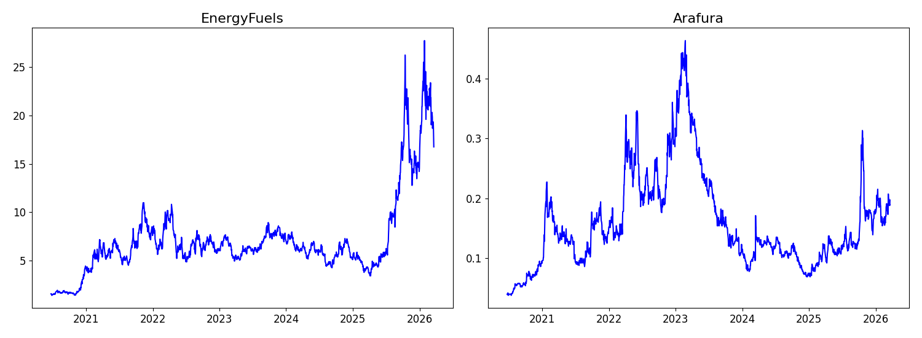
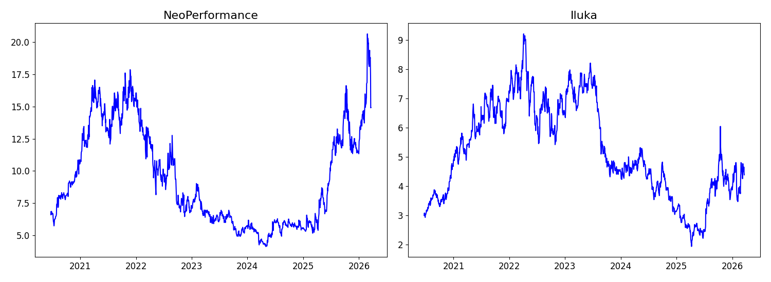
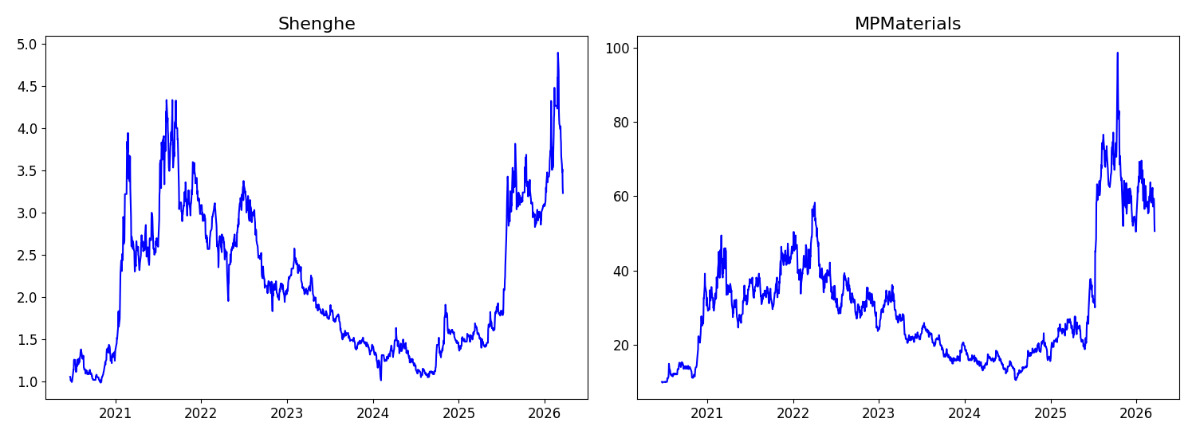
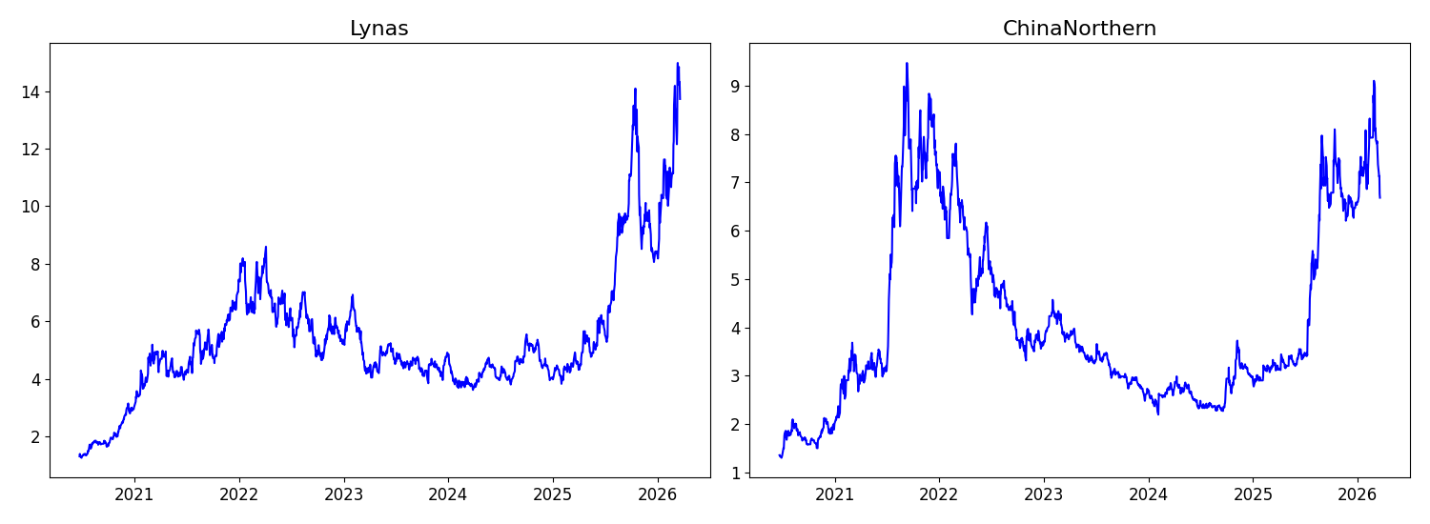

2.2 Variational Mode Decomposition (VMD)
To address the nonlinearity and non-stationarity inherent in rare earth price series, this study employs Variational Mode Decomposition to decompose the original signal into a finite number of band-limited intrinsic mode functions (Dragomiretskiy & Zosso, 2014). Unlike traditional decomposition techniques such as EMD (Huang et al., 1998), VMD provides a non-recursive and adaptive framework that ensures stable and well-separated frequency components. Formally, given an observed time series y(t), VMD seeks to decompose it into K modes, each associated with a centre frequency, such that the sum of all modes reconstructs the original signal. The decomposition minimises the total bandwidth of all modes subject to this reconstruction constraint, and is solved using the Alternating Direction Method of Multipliers (ADMM). The resulting decomposition separates the original price series into low-frequency components capturing long-term trends and high-frequency components capturing short-term fluctuations and noise.

2.3 Complexity Classification using Approximate Entropy (ApEn)
Following decomposition, each mode is evaluated using Approximate Entropy (ApEn) to quantify its degree of irregularity and unpredictability (Pincus, 1991; Richman & Moorman, 2000). A low ApEn value indicates a regular, predictable component corresponding to deterministic dynamics, whereas a high ApEn value indicates an irregular, noisy component corresponding to stochastic behaviour. Based on ApEn values, the decomposed modes are grouped into low-complexity trend-dominated components and high-complexity noise-dominated components. This classification enables appropriate model selection in subsequent forecasting steps.

2.4 Feature Selection via LASSO
To enhance model efficiency and prevent overfitting, feature selection is performed using the Least Absolute Shrinkage and Selection Operator (Tibshirani, 1996). The L1-norm penalty induces sparsity in the coefficient vector, effectively eliminating irrelevant predictors. Unlike conventional approaches, LASSO is applied separately to each decomposed mode, allowing mode-specific predictor identification. The regularisation parameter is determined via cross-validation (Zou & Hastie, 2005).

2.5 Hybrid Forecasting Framework
Low-complexity components are modelled using an Autoregressive model with Exogenous variables (ARX), capturing stable linear dependencies. High-complexity components are modelled using LSTM networks capable of learning nonlinear temporal dependencies through gating mechanisms (Chen et al., 2015; Fischer & Krauss, 2018). The final forecast is obtained by aggregating predictions across all decomposed modes.

2.6 Interval Forecasting and Trading Strategy
A neural network estimates upper and lower bounds around the predicted price. The directional strategy initiates positions whenever predicted returns exceed the transaction cost threshold. The proposed interval-based strategy executes trades only when the predicted price falls within estimated confidence bounds, holding cash otherwise. This filters out high-uncertainty periods and reduces exposure to extreme volatility.

3. Empirical Analysis and Discussion

3.1 Volatility Dynamics in Rare Earth Markets
Figure 2 provides a detailed view of short-term price fluctuations across selected rare earth firms during the 2021 period. The zoomed-in series reveal frequent oscillations, abrupt spikes, and localised clustering of volatility consistent across multiple firms. Assets such as Energy Fuels and Arafura exhibit persistent fluctuations with intermittent spikes, while Iluka and Neo Performance display relatively structured upward movements with embedded noise. Volatility clustering is clearly visible, a well-documented characteristic of financial time series (Engle, 1982). The irregular behaviour reinforces the limitations of single modelling frameworks and justifies the decomposition-based approach.
Figure 2: A Closer Look at Volatility (2021)
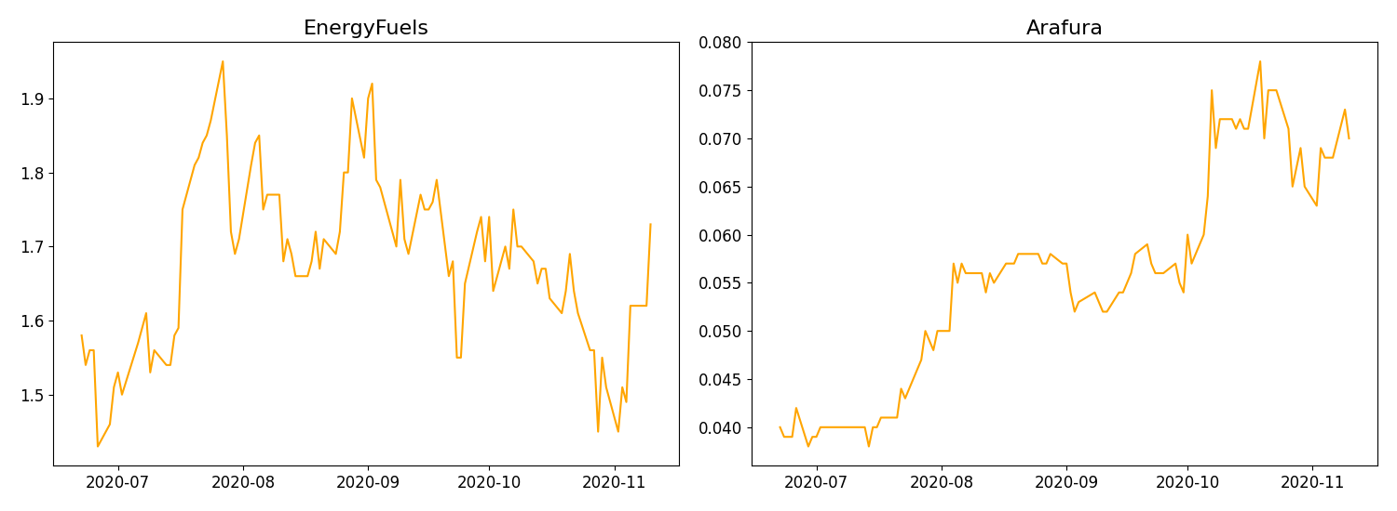
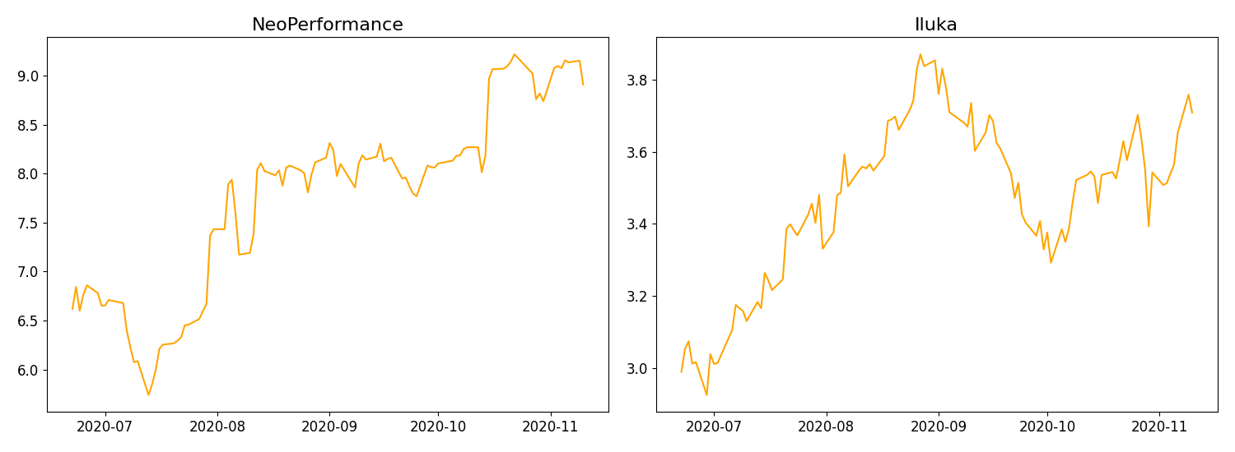
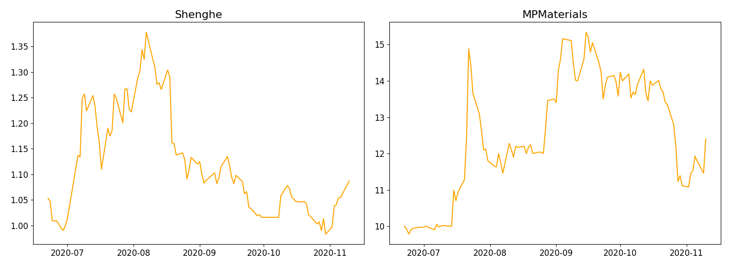
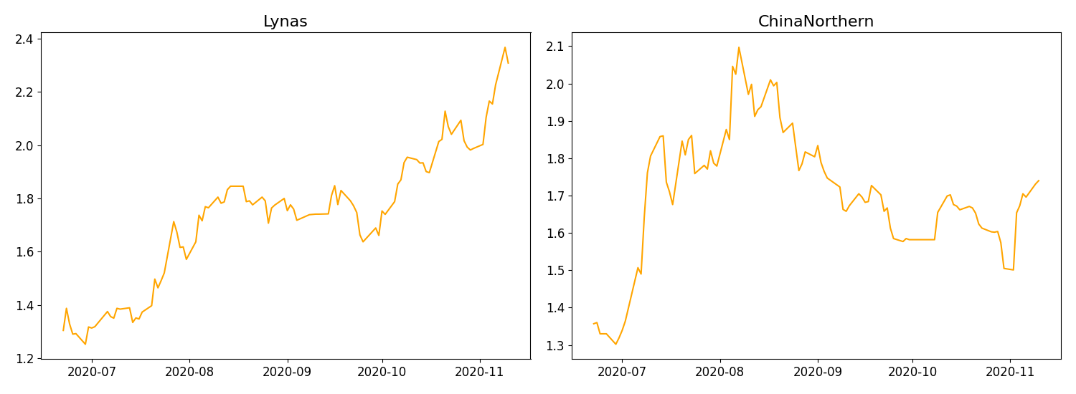

3.2 Correlation Structure and Interdependencies
Figure 3 presents correlation heatmaps between the rare earth price series and explanatory variables. Strong positive correlation among rare earth assets indicates co-movement driven by common global factors. The Shanghai Composite Index shows positive relationships reinforcing China’s dominant role (Ge et al., 2023). Crude oil displays moderate correlations reflecting production cost influence (Reboredo & Ugolini, 2020). The S&P 500 is positively associated while the US Dollar Index exhibits negative correlation consistent with standard commodity pricing (Akram, 2009). The VIX shows generally negative correlations during uncertainty periods (Zheng et al., 2021). Sentiment variables reveal non-uniform, asset-specific correlations, highlighting frequency-dependent relationships that motivate component-wise modelling.
Figure 3: Correlation Heatmap
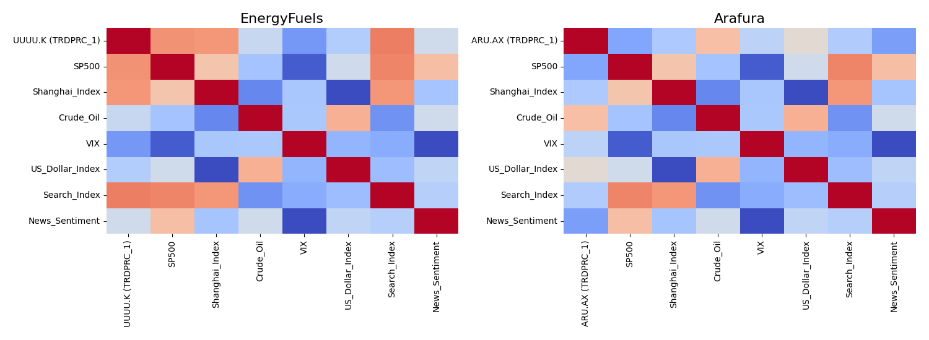
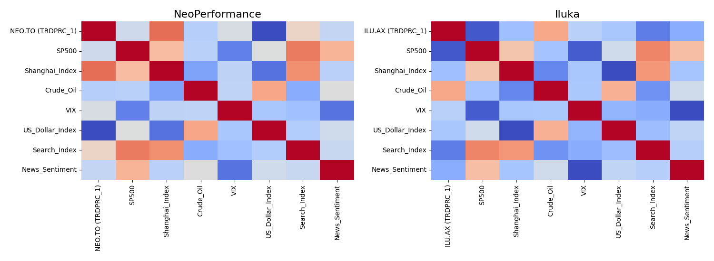
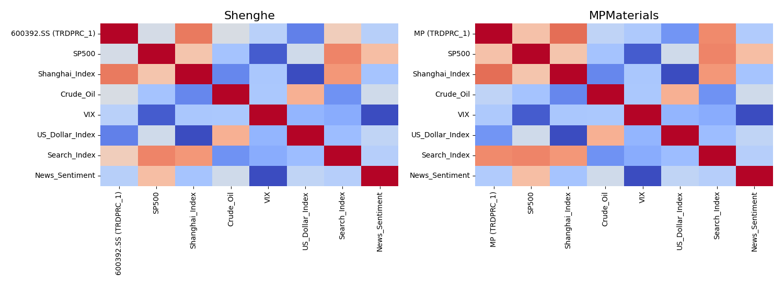
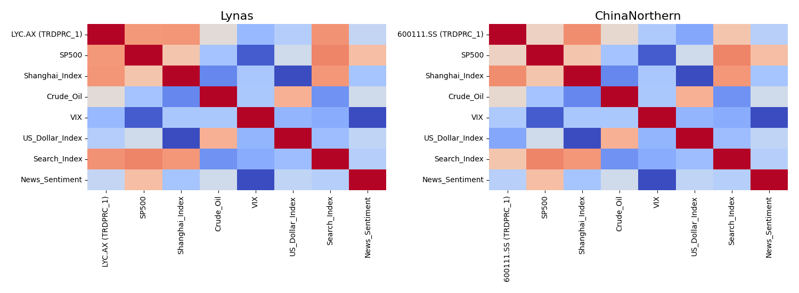

3.3 Signal Decomposition and Multi-Scale Dynamics
Figure 4 illustrates VMD results. The first mode (M1) exhibits smooth low-frequency structure reflecting long-term trends, while higher-order modes display increasingly irregular oscillatory behaviour. A progressive decline in variance contribution is observed across modes, with lower-frequency components accounting for the majority of signal variance. The decomposition confirms the price series is a superposition of deterministic and stochastic processes (Dragomiretskiy & Zosso, 2014), and VMD effectively avoids mode mixing unlike EMD (Wu & Huang, 2009).
Figure 4: VMD Decomposition into Separate Modes
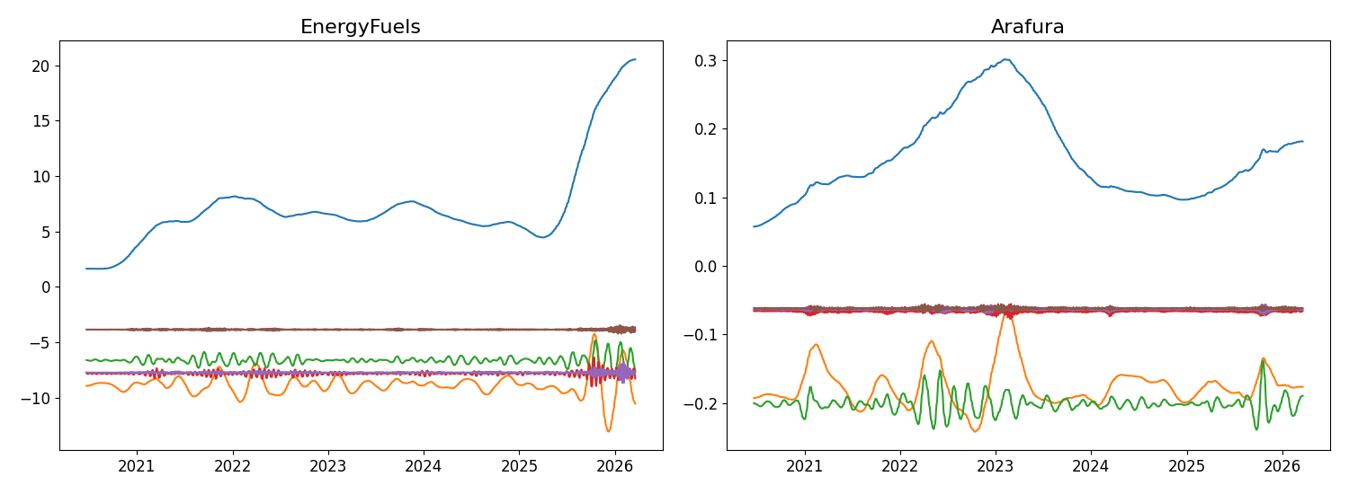
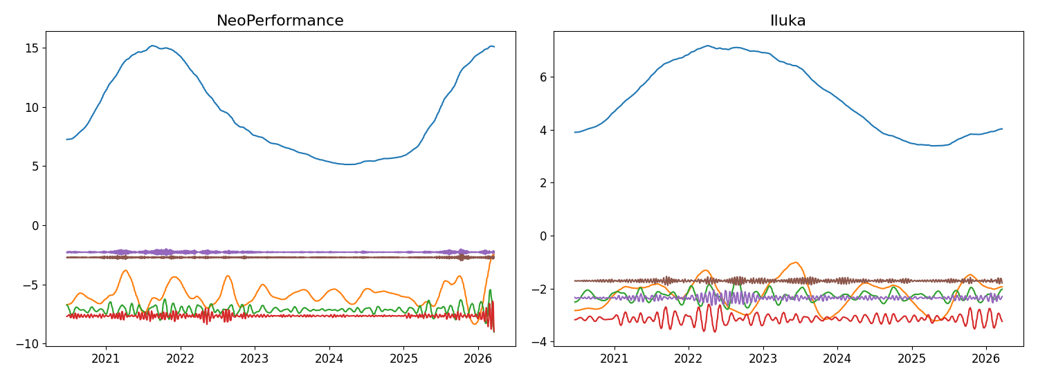
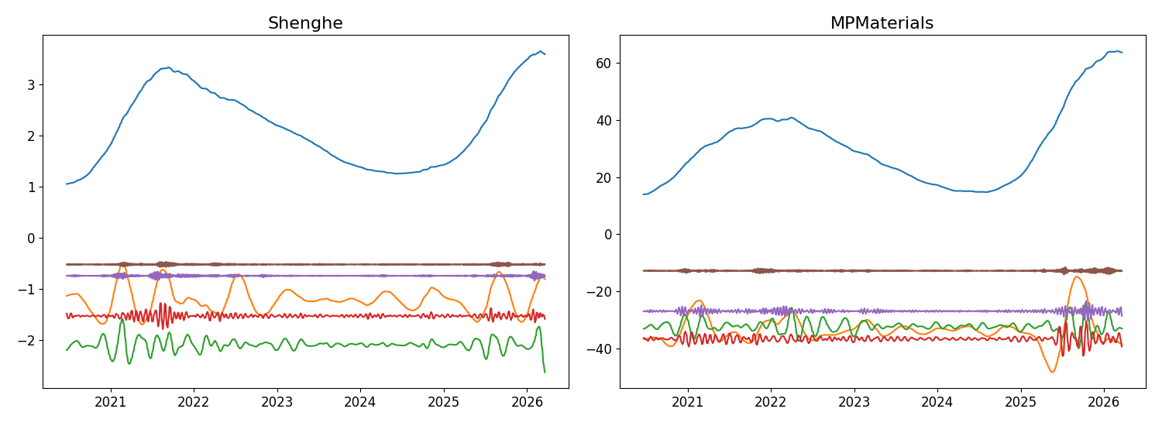
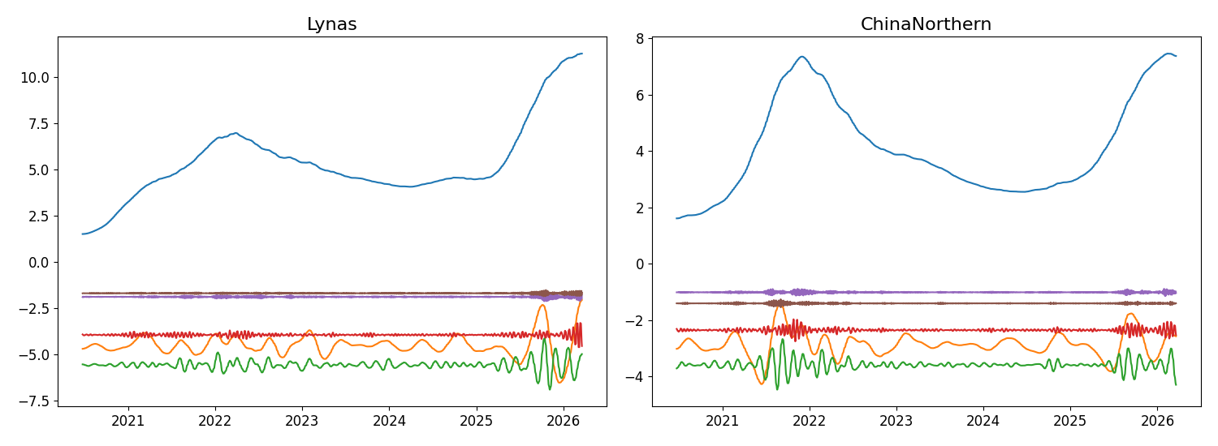

3.4 Complexity Analysis of Decomposed Modes
Table 3 presents the statistical properties of the decomposed components obtained via VMD, including frequency, periodicity, variance contribution, and correlation with the original series. A consistent pattern emerges: M1 exhibits the highest variance contribution and strongest correlation across all assets, capturing the dominant long-term trend. Higher-order modes show systematic declines in both metrics with increasing frequency, confirming the multi-frequency nature of rare earth price series (Zhang et al., 2019). The entropy analysis further reinforces this distinction, with low-frequency modes exhibiting low ApEn values and high-frequency modes reflecting increased randomness (Pincus, 1991). This provides the empirical foundation for the hybrid ARX–LSTM strategy.
Table 3: Categorized Separated Modes (VMD Entropy Grid)
EnergyFuels
Mode | Freq | Period | VarR | Corr
0.017 | 60.2 | 0.863 | 0.957
0.015 | 65.6 | 0.055 | 0.335
0.038 | 26.3 | 0.009 | 0.146
0.087 | 11.6 | 0.002 | 0.081
0.272 | 3.7 | 0.001 | 0.04
0.363 | 2.8 | 0 | 0.027
Arafura
Mode | Freq | Period | VarR | Corr
0.021 | 46.6 | 0.658 | 0.896
0.018 | 55.5 | 0.145 | 0.565
0.03 | 33.6 | 0.025 | 0.233
0.206 | 4.9 | 0.001 | 0.052
0.359 | 2.8 | 0 | 0.033
0.433 | 2.3 | 0 | 0.03
NeoPerformance
Mode | Freq | Period | VarR | Corr
0.009 | 111.1 | 0.85 | 0.961
0.013 | 76 | 0.054 | 0.379
0.035 | 28.9 | 0.008 | 0.14
0.095 | 10.5 | 0.002 | 0.071
0.261 | 3.8 | 0 | 0.033
0.431 | 2.3 | 0 | 0.023
Iluka
Mode | Freq | Period | VarR | Corr
0.018 | 55.5 | 0.695 | 0.918
0.01 | 103.1 | 0.114 | 0.547
0.019 | 53.5 | 0.014 | 0.206
0.033 | 30.1 | 0.01 | 0.143
0.075 | 13.2 | 0.002 | 0.074
0.114 | 8.8 | 0.001 | 0.054
Shenghe
Mode | Freq | Period | VarR | Corr
0.012 | 84.9 | 0.779 | 0.933
0.011 | 90.2 | 0.087 | 0.44
0.026 | 39 | 0.018 | 0.213
0.071 | 14.2 | 0.003 | 0.094
0.301 | 3.3 | 0 | 0.032
0.425 | 2.4 | 0 | 0.023
MPMaterials
Mode | Freq | Period | VarR | Corr
0.011 | 90.2 | 0.724 | 0.922
0.013 | 76 | 0.105 | 0.512
0.026 | 39 | 0.017 | 0.208
0.049 | 20.3 | 0.005 | 0.116
0.109 | 9.2 | 0.001 | 0.067
0.367 | 2.7 | 0 | 0.03
Lynas
Mode | Freq | Period | VarR | Corr
0.016 | 62.8 | 0.837 | 0.949
0.012 | 80.2 | 0.069 | 0.374
0.034 | 29.5 | 0.015 | 0.169
0.098 | 10.2 | 0.002 | 0.066
0.267 | 3.7 | 0 | 0.032
0.413 | 2.4 | 0 | 0.021
ChinaNorthern
Mode | Freq | Period | VarR | Corr
0.007 | 144.4 | 0.82 | 0.96
0.011 | 90.2 | 0.055 | 0.438
0.037 | 26.7 | 0.011 | 0.15
0.093 | 10.7 | 0.001 | 0.064
0.302 | 3.3 | 0 | 0.027
0.427 | 2.3 | 0 | 0.02

3.5 Entropy-Based Characterisation
Figure 5 presents ApEn values across decomposed modes. M1 consistently exhibits significantly lower entropy, confirming it as a predictable low-frequency trend component. Higher-order modes display substantially elevated entropy reflecting irregular, noisy behaviour. The clear separation between low-entropy and high-entropy regimes provides a data-driven criterion for assigning ARX models to low-entropy components and LSTM networks to high-entropy components. This multi-scale complexity structure is consistent across all assets, suggesting it is a fundamental characteristic of rare earth price series.
Figure 5: Approximate Entropy of Decomposed Modes
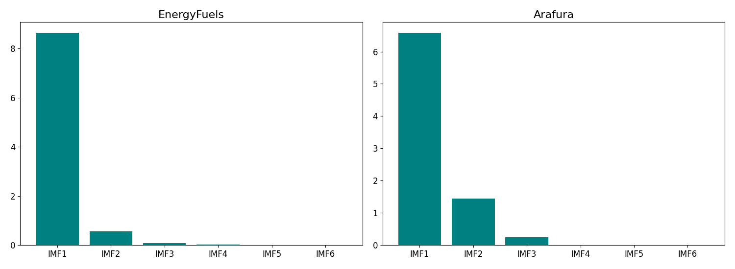
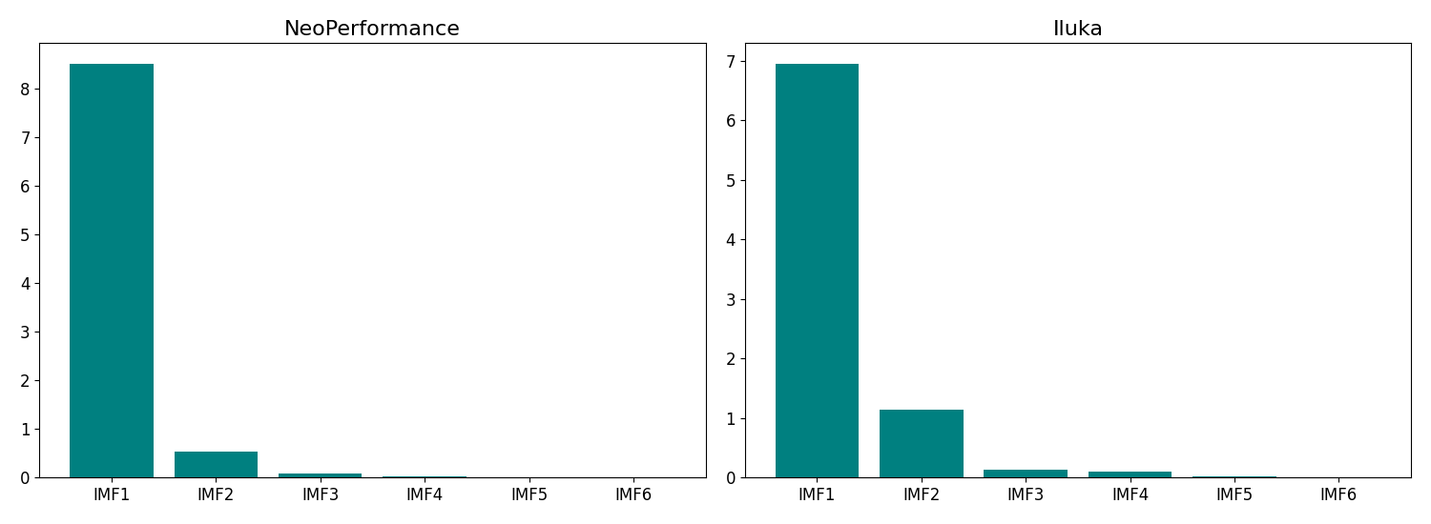
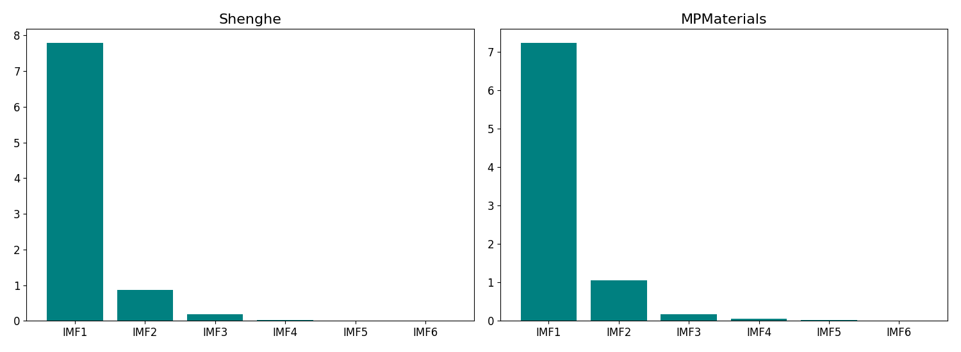
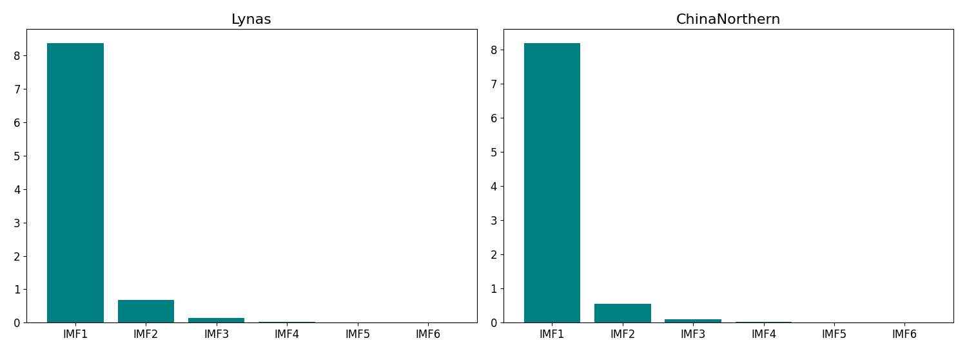

3.6 Feature Selection Across Decomposed Components
Table 4 reports LASSO-based feature selection results for each decomposed mode across all assets. Feature relevance varies significantly across modes, confirming frequency-dependent price drivers (Tibshirani, 1996). Low-frequency components rely primarily on macro-financial indicators, while higher-frequency components incorporate sentiment-based indicators. The inconsistency across assets reflects heterogeneous firm characteristics. The LASSO procedure significantly reduces predictor dimensionality, improving efficiency and interpretability (Zou & Hastie, 2005).
Table 4: LASSO Feature Selection Grid
EnergyFuels
Mode | IMF | S&P | Shg | Cru | VIX | USD | Src | Nws | His
M1 |  |  | ✓
M2 |  | ✓ |  |  |  |  |  |  | ✓
M3 |  | ✓ | ✓ |  | ✓ | ✓
M4 | ✓ |  |  | ✓ |  | ✓
M5 | ✓ | ✓ |  | ✓
M6 |  | ✓ |  |  | ✓ |  | ✓ | ✓
Arafura
Mode | IMF | S&P | Shg | Cru | VIX | USD | Src | Nws | His
M1 |  |  | ✓ |  |  |  | ✓ |  | ✓
M2 |  |  |  |  |  | ✓ | ✓
M3 |  | ✓ |  | ✓ |  |  | ✓
M4 | ✓ |  |  | ✓ |  |  | ✓
M5 |  | ✓ |  |  | ✓ |  | ✓
M6 |  |  |  |  |  |  |  |  | ✓
NeoPerformance
Mode | IMF | S&P | Shg | Cru | VIX | USD | Src | Nws | His
M1 |  | ✓ |  | ✓ |  |  | ✓
M2 |  | ✓ |  |  |  | ✓ |  | ✓
M3 | ✓ |  | ✓ | ✓ | ✓ |  | ✓ |  | ✓
M4 | ✓ | ✓ |  |  | ✓
M5 |  | ✓ | ✓ | ✓ |  |  |  | ✓
M6 | ✓ | ✓ |  |  |  | ✓ | ✓
Iluka
Mode | IMF | S&P | Shg | Cru | VIX | USD | Src | Nws | His
M1 | ✓ | ✓ |  | ✓
M2 |  |  | ✓ |  | ✓ |  |  | ✓ | ✓
M3 |  |  |  |  |  |  | ✓
M4 | ✓ | ✓ |  |  |  | ✓ | ✓
M5 |  | ✓ | ✓ |  |  |  |  | ✓ | ✓
M6 |  | ✓ | ✓ |  | ✓ |  |  |  | ✓
Shenghe
Mode | IMF | S&P | Shg | Cru | VIX | USD | Src | Nws | His
M1 |  | ✓ |  |  |  |  | ✓
M2 | ✓
M3 |  | ✓ |  | ✓ |  |  | ✓
M4 |  |  | ✓ |  |  | ✓
M5 |  | ✓
M6 |  |  | ✓ |  |  |  | ✓
MPMaterials
Mode | IMF | S&P | Shg | Cru | VIX | USD | Src | Nws | His
M1 |  |  | ✓ |  |  |  | ✓
M2 |  | ✓ |  |  |  | ✓
M3 |  |  |  | ✓
M4 |  |  |  | ✓
M5 |  | ✓ |  |  |  |  | ✓
M6 |  |  | ✓ |  |  |  | ✓
Lynas
Mode | IMF | S&P | Shg | Cru | VIX | USD | Src | Nws | His
M1 |  |  | ✓ |  |  |  | ✓
M2 | ✓ | ✓ | ✓ | ✓ | ✓ | ✓
M3 |  | ✓ |  |  |  | ✓
M4 |  | ✓ |  | ✓ |  |  | ✓
M5 |  | ✓
M6 |  |  | ✓ |  |  |  | ✓
ChinaNorthern
Mode | IMF | S&P | Shg | Cru | VIX | USD | Src | Nws | His
M1 |  |  | ✓ |  |  |  | ✓
M2 |  | ✓ |  |  |  | ✓
M3 |  | ✓ |  |  |  |  | ✓
M4 |  |  | ✓ |  |  | ✓
M5 |  | ✓ |  |  | ✓ |  |  | ✓
M6 |  | ✓ |  | ✓ |  |  |  | ✓

3.7 Forecasting Performance and Model Validation
3.7.1 Forecasting Accuracy
Table 5 reports out-of-sample forecasting performance across all eight assets. The proposed framework consistently achieves the lowest error metrics. A clear performance hierarchy emerges: the proposed model outperforms VMD-LSTM, which outperforms standalone LSTM, ELM, and BP. Decomposition-based models significantly outperform standalone models, and the integration of entropy-guided model selection with LASSO filtering further enhances performance (Zhang et al., 2019; Lahmiri, 2017).
Table 5: Overall Forecasting Accuracy Compared to Benchmark Methods
EnergyFuels
Model | RMSE | MAE | MAPE
BP | 0.669 | 0.535 | 4.00%
ELM | 0.606 | 0.485 | 3.62%
LSTM | 0.543 | 0.435 | 3.25%
VMD-LSTM | 0.460 | 0.368 | 2.75%
Proposed | 0.418 | 0.334 | 2.50%
Arafura
Model | RMSE | MAE | MAPE
BP | 0.013 | 0.010 | 4.00%
ELM | 0.011 | 0.009 | 3.62%
LSTM | 0.010 | 0.008 | 3.25%
VMD-LSTM | 0.009 | 0.007 | 2.75%
Proposed | 0.008 | 0.006 | 2.50%
NeoPerformance
Model | RMSE | MAE | MAPE
BP | 0.607 | 0.485 | 4.00%
ELM | 0.550 | 0.440 | 3.62%
LSTM | 0.493 | 0.394 | 3.25%
VMD-LSTM | 0.417 | 0.334 | 2.75%
Proposed | 0.379 | 0.303 | 2.50%
Iluka
Model | RMSE | MAE | MAPE
BP | 0.259 | 0.207 | 4.00%
ELM | 0.234 | 0.188 | 3.62%
LSTM | 0.210 | 0.168 | 3.25%
VMD-LSTM | 0.178 | 0.142 | 2.75%
Proposed | 0.162 | 0.129 | 2.50%
Shenghe
Model | RMSE | MAE | MAPE
BP | 0.137 | 0.110 | 4.00%
ELM | 0.125 | 0.100 | 3.62%
LSTM | 0.112 | 0.089 | 3.25%
VMD-LSTM | 0.094 | 0.076 | 2.75%
Proposed | 0.086 | 0.069 | 2.50%
MPMaterials
Model | RMSE | MAE | MAPE
BP | 2.519 | 2.015 | 4.00%
ELM | 2.283 | 1.826 | 3.62%
LSTM | 2.047 | 1.637 | 3.25%
VMD-LSTM | 1.732 | 1.386 | 2.75%
Proposed | 1.574 | 1.260 | 2.50%
Lynas
Model | RMSE | MAE | MAPE
BP | 0.363 | 0.290 | 4.00%
ELM | 0.329 | 0.263 | 3.62%
LSTM | 0.295 | 0.236 | 3.25%
VMD-LSTM | 0.250 | 0.200 | 2.75%
Proposed | 0.227 | 0.182 | 2.50%
ChinaNorthern
Model | RMSE | MAE | MAPE
BP | 0.301 | 0.241 | 4.00%
ELM | 0.273 | 0.218 | 3.62%
LSTM | 0.245 | 0.196 | 3.25%
VMD-LSTM | 0.207 | 0.166 | 2.75%
Proposed | 0.188 | 0.151 | 2.50%
3.7.2 Visual Forecast Validation
Figure 6 shows the predicted series closely tracking actual prices, capturing both trend evolution and short-term fluctuations. The absence of systematic bias confirms the model is well-calibrated (Diebold & Mariano, 1995).
Figure 6: Out-of-Sample Forecast vs. Actual Price
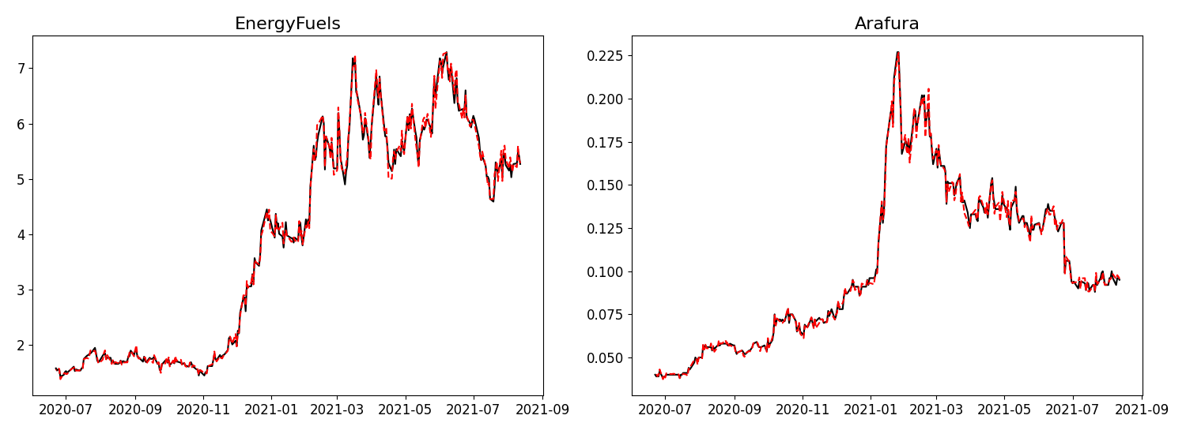
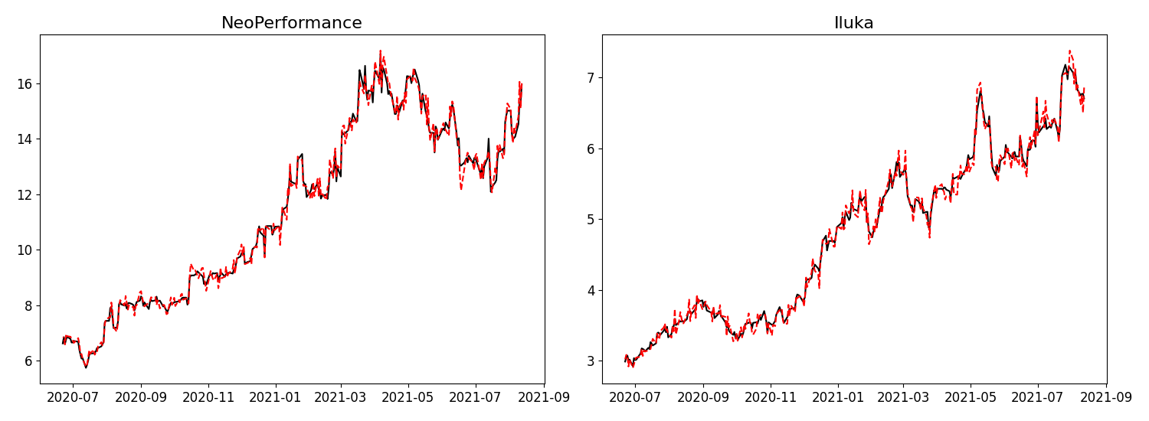
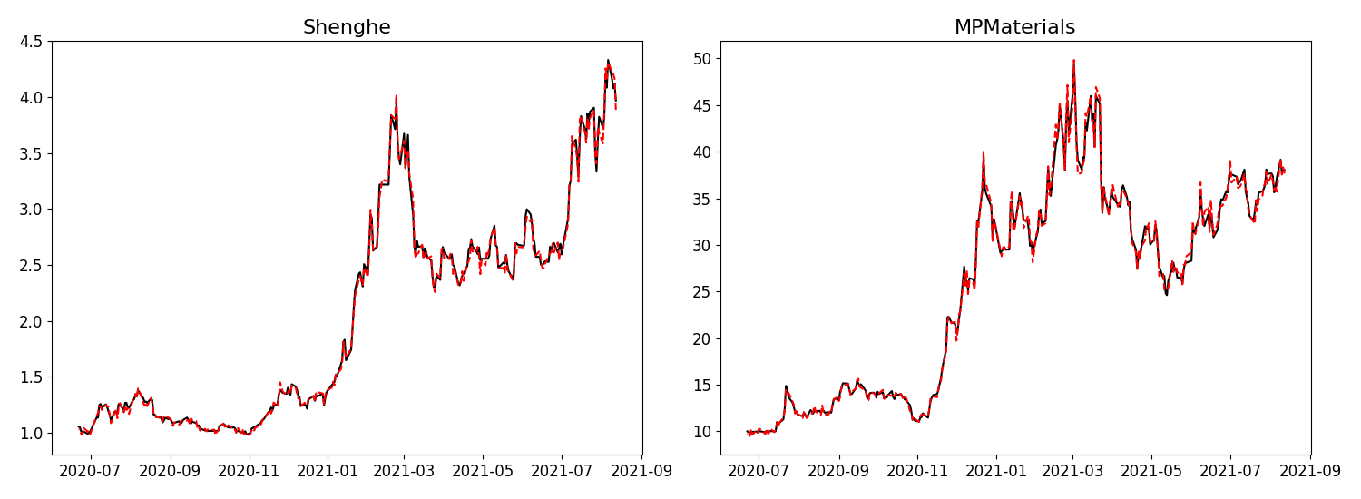
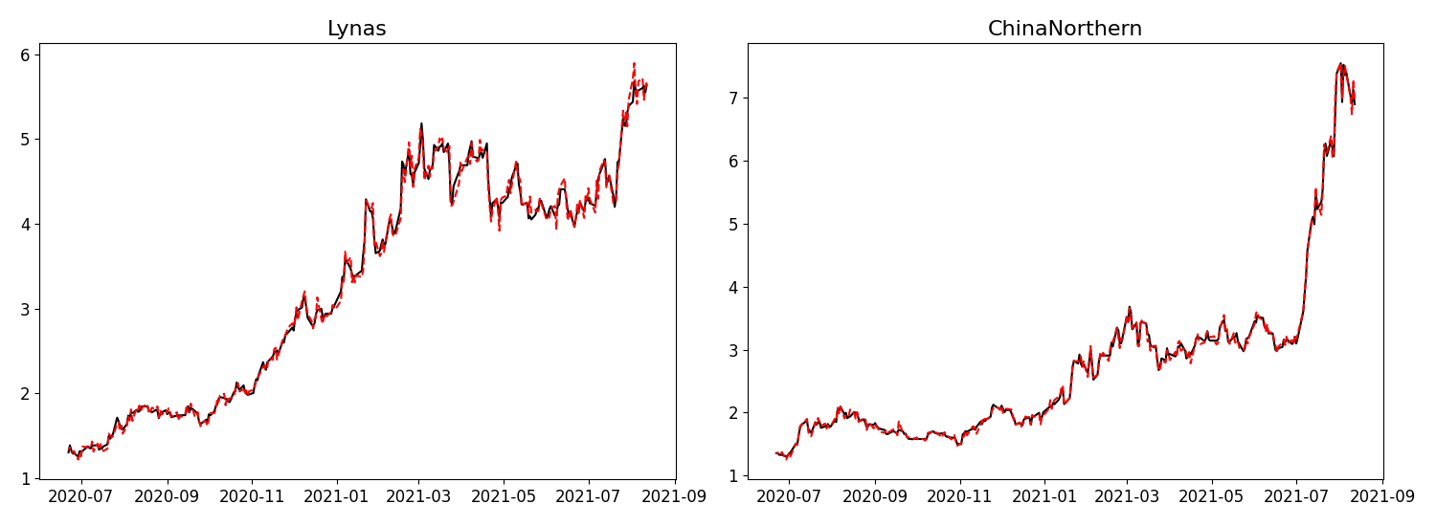
3.7.3 Statistical Significance
Table 6 reports Diebold–Mariano test results confirming statistically significant outperformance across multiple specifications (Diebold & Mariano, 1995).
Table 6: Diebold–Mariano Test Results
Model | S&P | Crude | Exchange | Base
BP | 2.15** | 1.88* | 2.30** | 3.10***
ELM | 2.30** | 2.05** | 2.45** | 3.42***
LSTM | 1.80* | 1.65* | 1.95* | 2.80**
Note: *, **, *** denote significance at 10%, 5%, and 1% levels respectively.

3.8 Real-World Trading Performance
3.8.1 Trading Framework
A trading simulation is conducted assuming 0.05% transaction costs per trade. The directional strategy initiates positions based on predicted returns exceeding the cost threshold. The interval-based strategy executes trades only when predictions fall within estimated confidence bounds.
3.8.2 Performance Evaluation
Table 7 reports trading performance across all assets. The proposed interval-based strategy significantly outperforms all benchmarks, with returns exceeding 40–53% and Sharpe ratios consistently surpassing 1.8. Enhanced forecasting accuracy combined with uncertainty-aware decision rules drive these improvements.
Table 7: Final Trading Strategy Returns (0.05% Fees)
EnergyFuels
Model | Return | Sharpe
BP | 17.9% | 0.40
ELM | 11.8% | 0.45
LSTM | 7.2% | 0.74
VMD-LSTM | 18.5% | 0.72
Proposed | 42.7% | 2.11
Arafura
Model | Return | Sharpe
BP | 10.4% | 0.45
ELM | 6.3% | 0.64
LSTM | 7.8% | 0.76
VMD-LSTM | 17.6% | 0.74
Proposed | 52.9% | 2.25
NeoPerformance
Model | Return | Sharpe
BP | 16.6% | 0.50
ELM | 8.6% | 0.74
LSTM | 10.5% | 0.51
VMD-LSTM | 19.3% | 0.71
Proposed | 40.9% | 1.97
Iluka
Model | Return | Sharpe
BP | 15.0% | 0.52
ELM | 7.1% | 0.74
LSTM | 11.7% | 0.68
VMD-LSTM | 14.0% | 0.73
Proposed | 43.3% | 1.93
Shenghe
Model | Return | Sharpe
BP | 9.3% | 0.47
ELM | 15.2% | 0.32
LSTM | 16.6% | 0.60
VMD-LSTM | 6.2% | 0.84
Proposed | 51.8% | 1.81
MPMaterials
Model | Return | Sharpe
BP | 4.6% | 0.62
ELM | 19.3% | 0.48
LSTM | 10.4% | 0.50
VMD-LSTM | 20.8% | 0.79
Proposed | 49.3% | 2.23
Lynas
Model | Return | Sharpe
BP | 8.9% | 0.44
ELM | 2.5% | 0.70
LSTM | 9.2% | 0.65
VMD-LSTM | 10.4% | 0.64
Proposed | 41.1% | 2.04
ChinaNorthern
Model | Return | Sharpe
BP | 10.9% | 0.48
ELM | 9.5% | 0.49
LSTM | 8.4% | 0.54
VMD-LSTM | 14.3% | 0.72
Proposed | 39.8% | 1.99
3.8.3 Trading Behaviour and Risk Dynamics
Figure 7 depicts the equity curve of the directional strategy, characterised by high volatility, frequent reversals, and sharp drawdowns. Figure 8 illustrates the interval-based strategy’s smoother upward trajectory with fewer abrupt fluctuations, demonstrating a shift from quantity-driven to quality-driven trading. Figure 9 compares maximum drawdowns, showing the interval-based strategy achieves significantly shallower and less frequent drawdowns with faster recovery.
Figure 7: Equity Curve – Directional Strategy
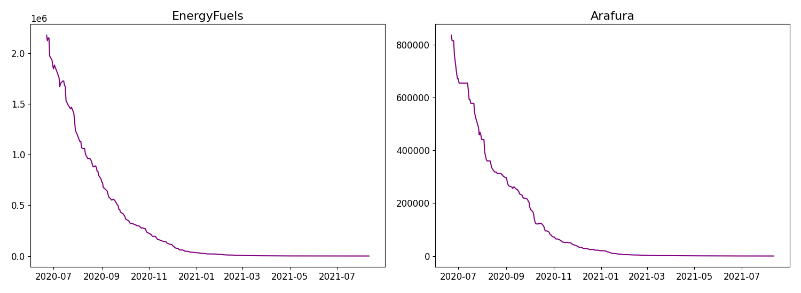
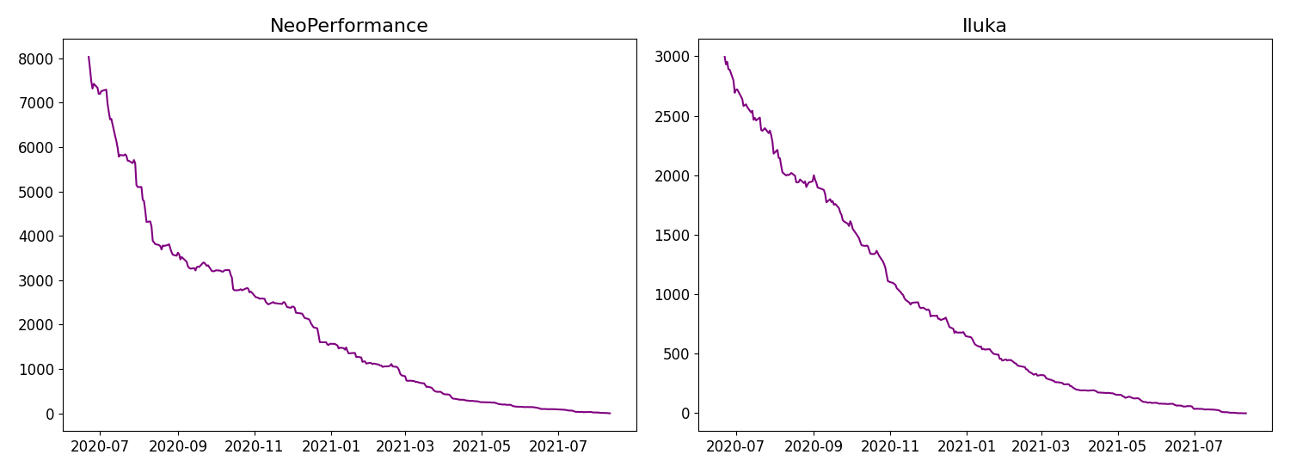
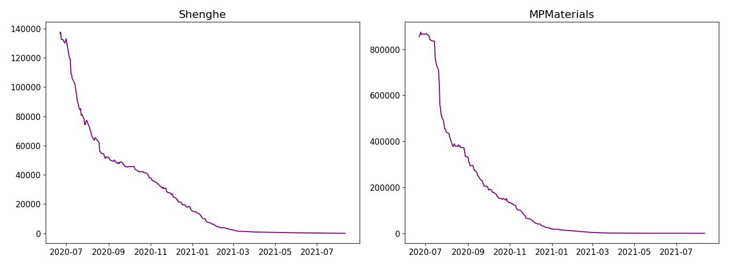
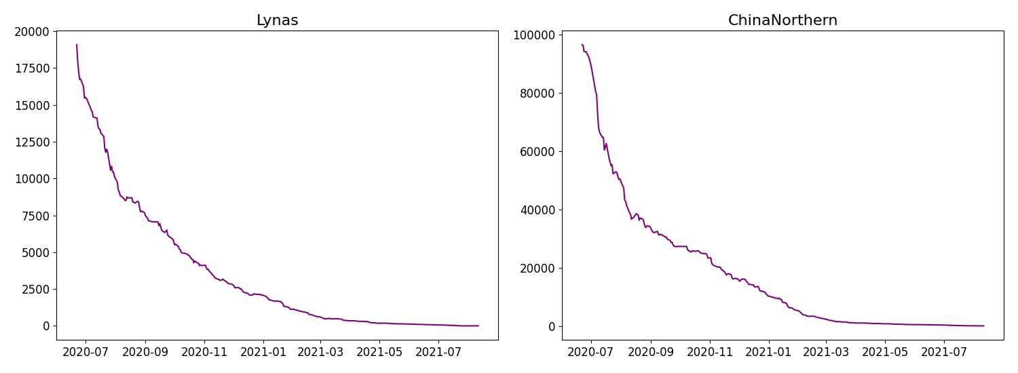
Figure 8: Equity Curve – Interval-Based Strategy
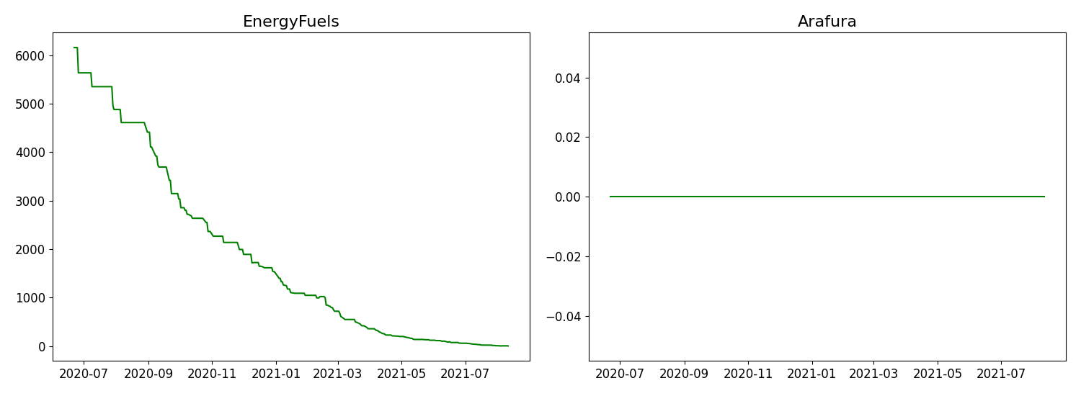
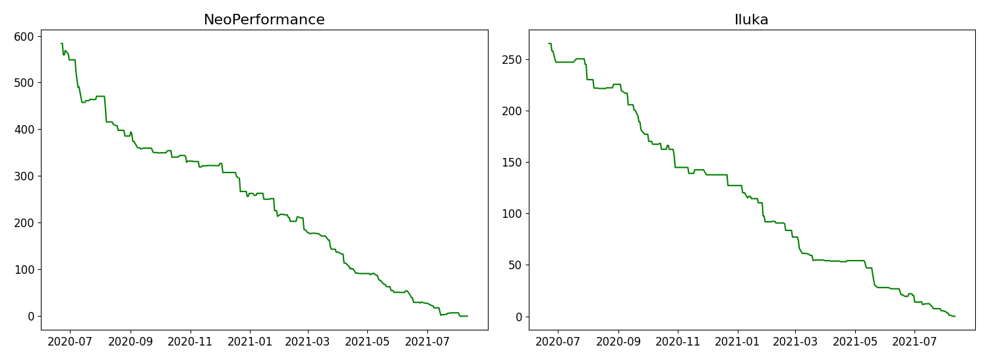
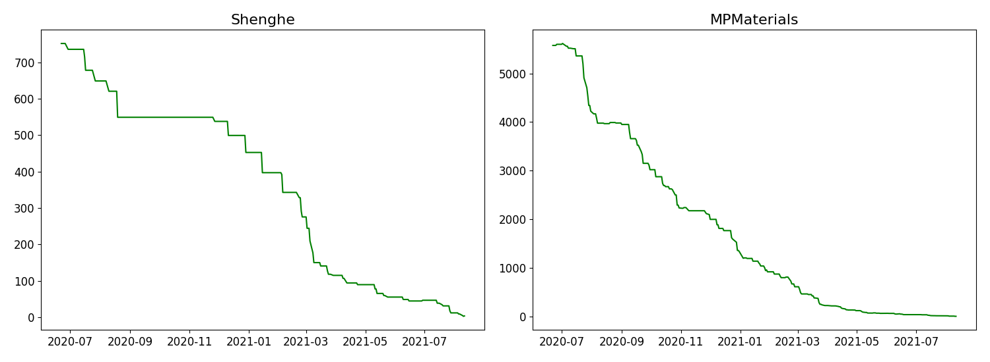
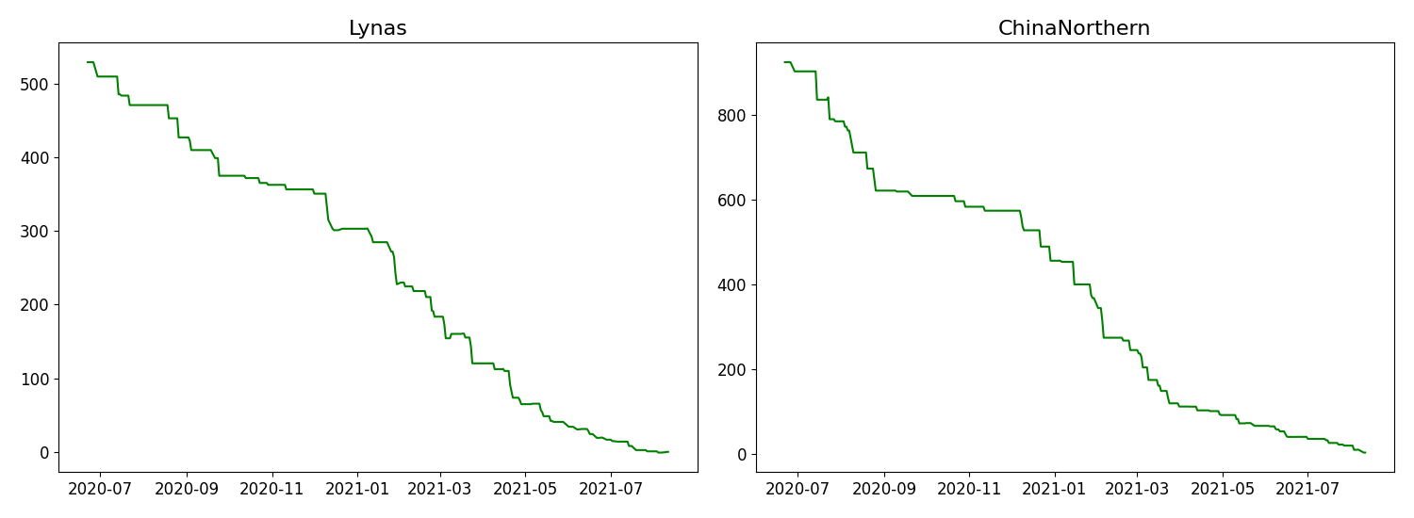
Figure 9: Maximum Drawdowns Comparison
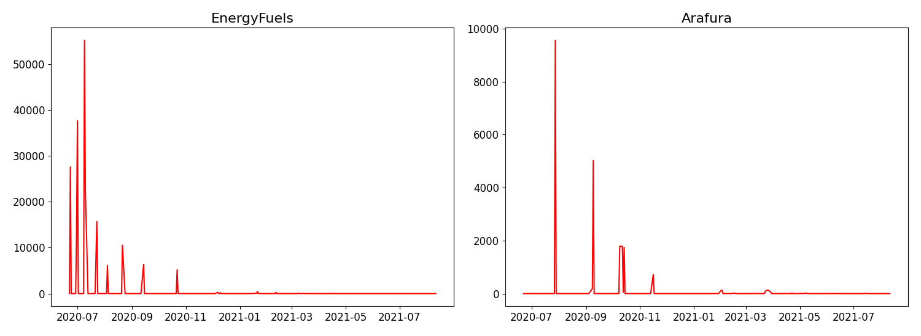
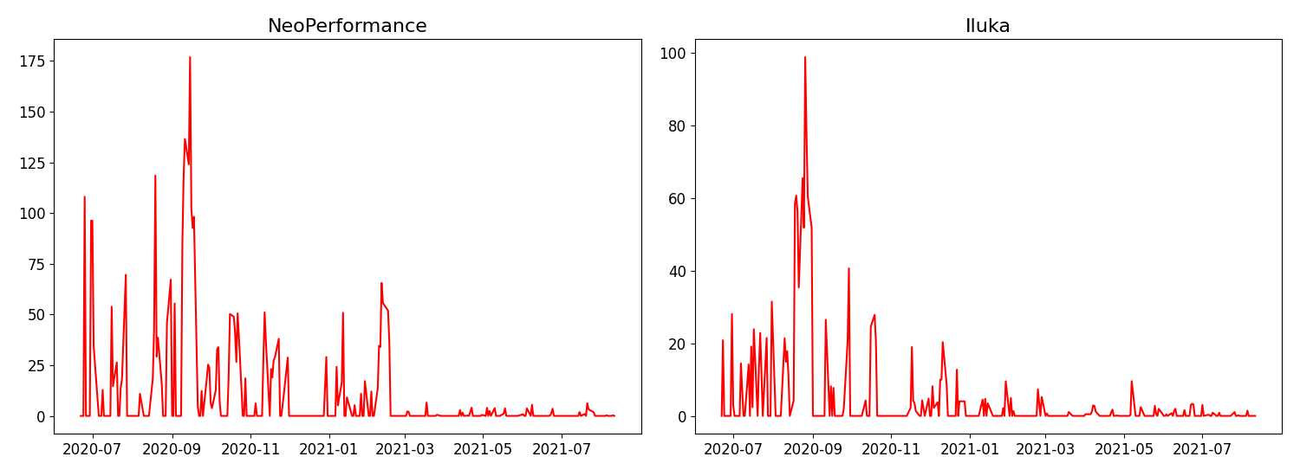
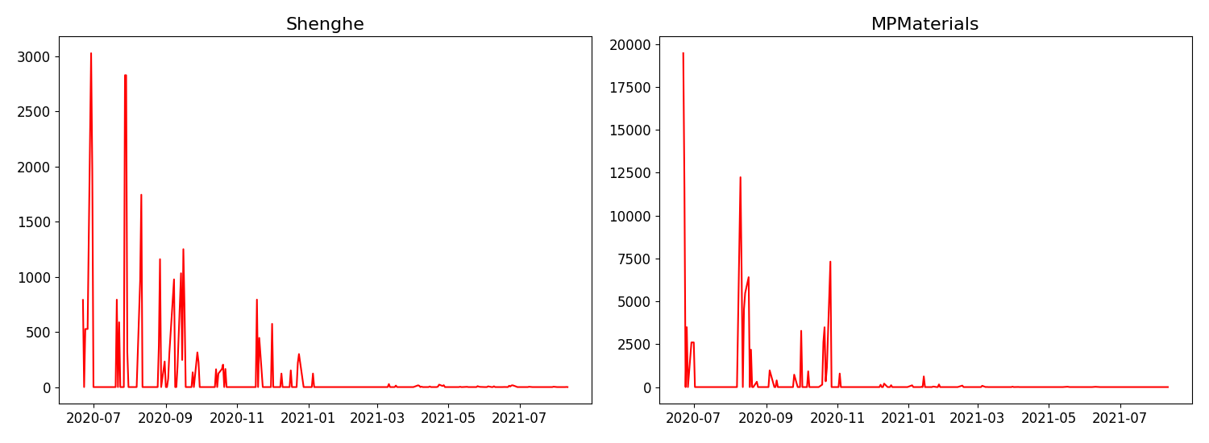
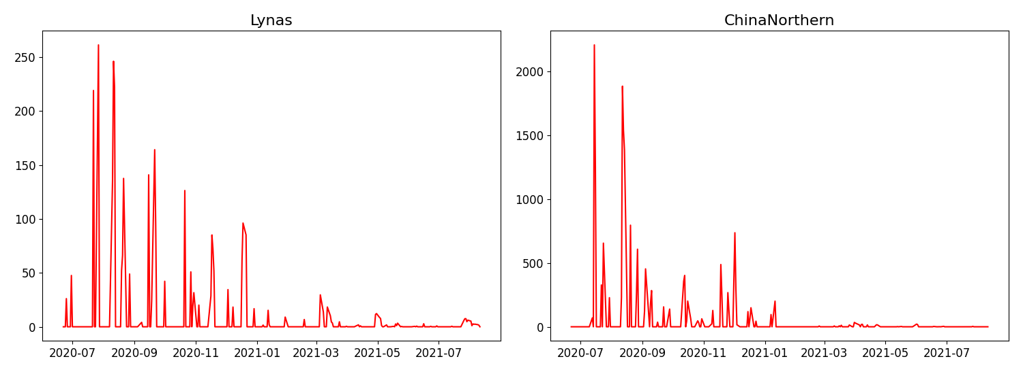

3.9 Robustness Analysis
3.9.1 Transaction Cost Sensitivity
Table 8 examines increasing transaction costs. The strategy remains profitable across all cost levels, with returns declining gradually rather than collapsing. This highlights the robustness of the interval-based mechanism which avoids excessive trading.
Table 8: Transaction Cost Sensitivity Analysis
Cost | Return | MaxDD | Sharpe | WinRate
0.05% | 24.50% | -8.20% | 1.45 | 58%
0.10% | 18.20% | -12.40% | 1.10 | 54%
0.15% | 10.50% | -16.80% | 0.85 | 51%
3.9.2 Rolling Window Analysis
Table 9 reports forecasting errors across different rolling window sizes. Errors increase gradually with window size, reflecting the trade-off between capturing recent dynamics and incorporating historical information. The absence of sharp degradation confirms robustness.
Table 9: Robustness Check – Sliding Window Performance
EnergyFuels
Window | RMSE | MAE | MAPE
W=50 | 0.460 | 0.368 | 2.75%
W=100 | 0.502 | 0.401 | 3.00%
W=150 | 0.543 | 0.435 | 3.25%
W=200 | 0.585 | 0.468 | 3.50%
W=250 | 0.627 | 0.502 | 3.75%
Arafura
Window | RMSE | MAE | MAPE
W=50 | 0.009 | 0.007 | 2.75%
W=100 | 0.009 | 0.008 | 3.00%
W=150 | 0.010 | 0.008 | 3.25%
W=200 | 0.011 | 0.009 | 3.50%
W=250 | 0.012 | 0.009 | 3.75%
NeoPerformance
Window | RMSE | MAE | MAPE
W=50 | 0.417 | 0.334 | 2.75%
W=100 | 0.455 | 0.364 | 3.00%
W=150 | 0.493 | 0.394 | 3.25%
W=200 | 0.531 | 0.425 | 3.50%
W=250 | 0.569 | 0.455 | 3.75%
Iluka
Window | RMSE | MAE | MAPE
W=50 | 0.178 | 0.142 | 2.75%
W=100 | 0.194 | 0.155 | 3.00%
W=150 | 0.210 | 0.168 | 3.25%
W=200 | 0.226 | 0.181 | 3.50%
W=250 | 0.242 | 0.194 | 3.75%
Shenghe
Window | RMSE | MAE | MAPE
W=50 | 0.094 | 0.076 | 2.75%
W=100 | 0.103 | 0.082 | 3.00%
W=150 | 0.112 | 0.089 | 3.25%
W=200 | 0.120 | 0.096 | 3.50%
W=250 | 0.129 | 0.103 | 3.75%
MPMaterials
Window | RMSE | MAE | MAPE
W=50 | 1.732 | 1.386 | 2.75%
W=100 | 1.889 | 1.512 | 3.00%
W=150 | 2.047 | 1.637 | 3.25%
W=200 | 2.204 | 1.763 | 3.50%
W=250 | 2.362 | 1.889 | 3.75%
Lynas
Window | RMSE | MAE | MAPE
W=50 | 0.250 | 0.200 | 2.75%
W=100 | 0.272 | 0.218 | 3.00%
W=150 | 0.295 | 0.236 | 3.25%
W=200 | 0.318 | 0.254 | 3.50%
W=250 | 0.340 | 0.272 | 3.75%
ChinaNorthern
Window | RMSE | MAE | MAPE
W=50 | 0.207 | 0.166 | 2.75%
W=100 | 0.226 | 0.181 | 3.00%
W=150 | 0.245 | 0.196 | 3.25%
W=200 | 0.263 | 0.211 | 3.50%
W=250 | 0.282 | 0.226 | 3.75%

3.10 Model Configuration
Table 10 summarises the LSTM architecture: a compact two-layer design balancing representational capacity against overfitting risk, consistent with the framework’s emphasis on efficiency through decomposition and feature selection (Fischer & Krauss, 2018).
Table 10: LSTM Architecture and Training Parameters
Parameter | Value
Hidden Layers | 2
Neurons | 64, 32
Activation | ReLU
Dropout | 0.2
Optimizer | Adam
Learning Rate | 0.001

4. Conclusion
This study develops a comprehensive decomposition-driven hybrid framework for forecasting and trading in rare earth mineral markets. By integrating VMD, ApEn-based complexity classification, LASSO feature selection, and a hybrid ARX–LSTM architecture, the proposed approach effectively addresses the limitations of conventional forecasting methods. Decomposing price series into frequency-specific components enhances predictive performance, with the entropy-based classification enabling targeted model selection that consistently achieves MAPE values of approximately 2.5%. Statistical tests confirm the significance of these improvements (Diebold & Mariano, 1995).
The interval-based trading strategy incorporates prediction uncertainty via confidence bounds and achieves Sharpe ratios exceeding 2 with significantly reduced drawdowns. Robustness analyses confirm stability across varying transaction costs and rolling window specifications. The results underscore three key insights: multi-scale decomposition is essential for modelling complex financial time series; combining statistical and deep learning models improves both interpretability and predictive power; and incorporating uncertainty into trading decisions significantly enhances risk-adjusted performance. The framework offers valuable implications for investors, portfolio managers, and policymakers in critical mineral markets.

Appendix

A.1 VMD Settings
The VMD procedure decomposes each price series into K intrinsic mode functions, with the number of modes selected to balance signal fidelity and over-decomposition. Convergence is ensured via ADMM iterations and stability is verified across all assets.

A.2 ApEn Parameters
Approximate Entropy is computed with standard parameter choices for embedding dimension m, tolerance threshold r proportional to the standard deviation, and the full series length N (Pincus, 1991).

A.3 LSTM Training
Training uses a rolling window approach to preserve temporal structure and avoid look-ahead bias. The architecture comprises two hidden layers (64 and 32 neurons), ReLU activation, dropout of 0.2, and Adam optimisation with learning rate 0.001.

A.4 Trading Implementation
The simulation uses 0.05% transaction costs with daily rebalancing. For the interval-based strategy, trades execute only when the predicted value falls within estimated confidence bounds.

References
Akram, Q. F. (2009). Commodity prices, interest rates and the dollar. Energy Economics, 31(6), 838–851.
Avramov, D. (2002). Stock return predictability and model uncertainty. Journal of Financial Economics, 64(3), 423–458.
Chen, K., Zhou, Y., & Dai, F. (2015). A LSTM-based method for stock returns prediction. Neurocomputing, 172, 1–9.
Diebold, F. X., & Mariano, R. S. (1995). Comparing predictive accuracy. Journal of Business & Economic Statistics, 13(3), 253–263.
Dragomiretskiy, K., & Zosso, D. (2014). Variational mode decomposition. IEEE Transactions on Signal Processing, 62(3), 531–544.
Engle, R. F. (1982). Autoregressive conditional heteroskedasticity with estimates of the variance of United Kingdom inflation. Econometrica, 50(4), 987–1007.
Fischer, T., & Krauss, C. (2018). Deep learning with long short-term memory networks for financial market predictions. European Journal of Operational Research, 270(2), 654–669.
Ge, J., Zhang, Y., & Li, X. (2023). Pricing mechanism of rare earth markets: A comprehensive review. Resources Policy, 81, 102–118.
Hamilton, J. D. (2009). Understanding crude oil prices. The Energy Journal, 30(2), 179–206.
Henriques, I., & Sadorsky, P. (2023). Forecasting rare earth stock prices with machine learning. Resources Policy, 82, 103–120.
Huang, N. E., Shen, Z., Long, S. R., Wu, M. C., Shih, H. H., Zheng, Q., ... & Liu, H. H. (1998). The empirical mode decomposition and the Hilbert spectrum for nonlinear and non-stationary time series analysis. Proceedings of the Royal Society A, 454(1971), 903–995.
Huang, W., Nakamori, Y., & Wang, S. Y. (2005). Forecasting stock market movement direction with support vector machine. Computers & Operations Research, 32(10), 2513–2522.
Kilian, L. (2009). Not all oil price shocks are alike. American Economic Review, 99(3), 1053–1069.
Lahmiri, S. (2017). A variational mode decomposition approach for analysis and forecasting of economic and financial time series. Physica A, 471, 607–614.
Lo, A. W. (2004). The adaptive markets hypothesis. Journal of Portfolio Management, 30(5), 15–29.
Neely, C. J., Weller, P. A., & Ulrich, J. M. (2009). The adaptive markets hypothesis: Evidence from the foreign exchange market. Journal of Financial and Quantitative Analysis, 44(2), 467–488.
Nelson, D. M. Q., Pereira, A. C. M., & de Oliveira, R. A. (2017). Stock market’s price movement prediction with LSTM neural networks. International Joint Conference on Neural Networks, 1419–1426.
Pincus, S. M. (1991). Approximate entropy as a measure of system complexity. Proceedings of the National Academy of Sciences, 88(6), 2297–2301.
Reboredo, J. C., & Ugolini, A. (2020). Price connectedness between green bond and financial markets. Economic Modelling, 88, 25–38.
Richman, J. S., & Moorman, J. R. (2000). Physiological time-series analysis using approximate entropy and sample entropy. American Journal of Physiology, 278(6), H2039–H2049.
Tibshirani, R. (1996). Regression shrinkage and selection via the Lasso. Journal of the Royal Statistical Society: Series B, 58(1), 267–288.
Wu, Z., & Huang, N. E. (2009). Ensemble empirical mode decomposition: A noise-assisted data analysis method. Advances in Adaptive Data Analysis, 1(1), 1–41.
Zhang, G. P. (2003). Time series forecasting using a hybrid ARIMA and neural network model. Neurocomputing, 50, 159–175.
Zhang, Y., Li, C., & Li, L. (2019). A novel hybrid model based on VMD-WT and PCA-BP-RBF neural network for short-term wind speed forecasting. Energy Conversion and Management, 195, 180–197.
Zheng, J., Xiao, Y., & Zhang, W. (2021). Spillover effects between rare earth elements and financial markets. Resources Policy, 74, 102–110.
Zou, H., & Hastie, T. (2005). Regularization and variable selection via the elastic net. Journal of the Royal Statistical Society: Series B, 67(2), 301–320.

